LEARning management system FOR SYS college

zohaib waqar

ex dev & Technical business analyst

case study

01 may 2025

**Institution Overview**

Sys College is a higher education institution offering both vocational and degree-level programs to over **5,000 students**. The college comprises **5 faculties**. Arts, Science, Health Science, Engineering, and Social Sciences. Each subdivided into schools and departments.

**Organizational Structure**

This college has classical hierarchal structure, with each of **5 faculty** broken down into no of schools and each school broken down into no of departments each covering a particular subject.

1. **Functional View – College**
   * Faculties
   * Schools
   * Departments
2. **Functional View – Department**
   * Department Head
   * Senior Lecturers / Tutors – Subject Area Focus
   * Lecturers / Tutors – Subject Area and Subject Teaching
   * Administrative Staff – Operational Support

For a detailed visualization of this structure, please refer to **Appendix A: Organizational Chart**.

**Business Environment**

The college operates in a **highly competitive educational landscape**, where institutions compete for:

1. Top-tier academic, research, and teaching staff
2. High-achieving students
3. Commercial education opportunities

**Business Opportunity**

Most competitors prioritize research and commercial success, often **at the expense of teaching quality**. Sys College has identified this as a **key competitive gap** and seeks to differentiate itself through **teaching excellence**.

**Business Vision**

“To offer the best quality of education and teaching to our students and become the leading college for student teaching across all subjects.”

**Strategic Projects Supporting Vision**

|  |  |
| --- | --- |
| Project name | Objective |
| FSD | Reorganize faculties, schools, and departments to optimize teaching |
| Academic Recruitment | Hire top academic professionals across disciplines |
| LMS | Develop a comprehensive LMS and admin platform to support teaching |

In terms of project delivery college have realized that they are college and they have very bright people working for them. Therefore, the overall approach will be to do it themselves as soon as possible.

**Project: LMS (Focus of This Case Study)**

**Goal:** To design and implement a modern LMS that aligns with the college’s teaching-focused vision and improves the educational experience for students and teaching staff.

**Dual Viewpoints (BA Consideration)**

|  |  |
| --- | --- |
| Viewpoint | Goals |
| Commercial VP | More students, higher revenue |
| Educational VP | Better student experience, learning quality |

**Appendix A**

**ORGANIZATIONAL CHART**

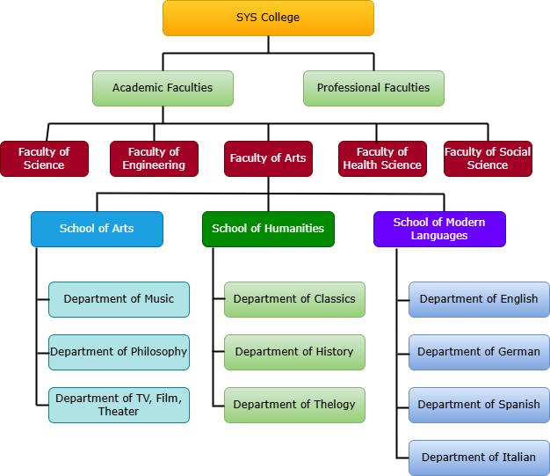

Figure A1: Sys College Organizational Structure

This diagram illustrates the hierarchical structure of Sys College, showing the breakdown from the college level into faculties, schools, and departments.